**PROXIMITY SENSOR**

INSTRUCTION MANUAL

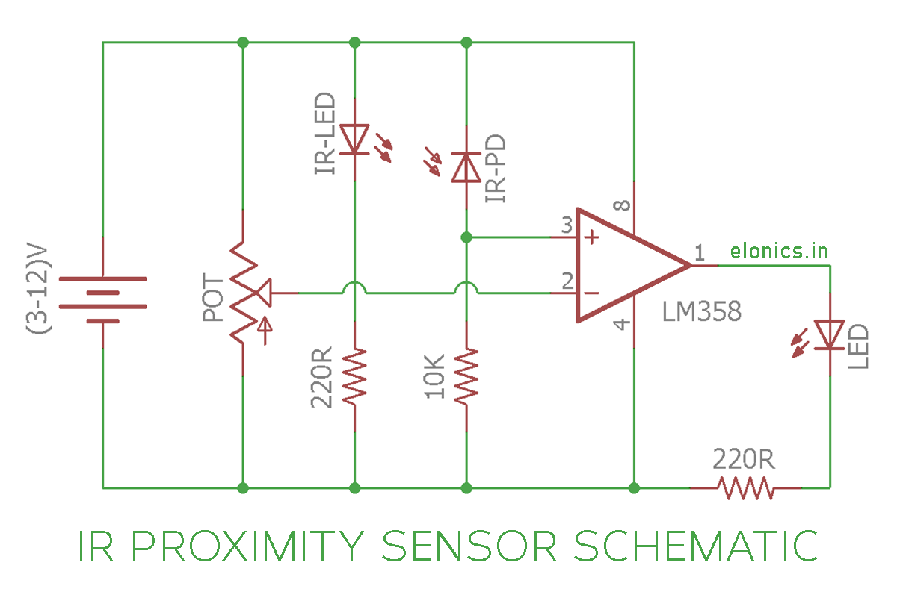

1. Connect a battery to the bottommost 2 terminals of the breadboard.

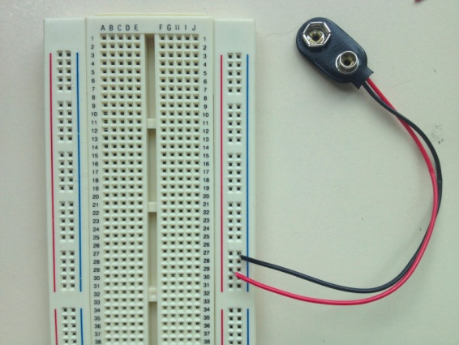

2. Connect the LM358(Op-amp comparator) IC across the breadboard like this:

From the notch moving in anti-clockwise direction are pins 1,2,3….etc. till 8.

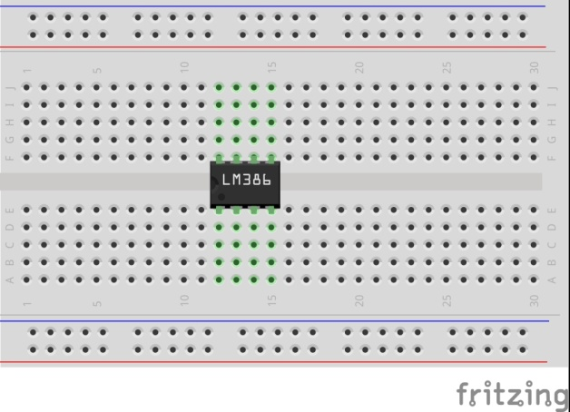

3. Connect the IR led and Photo diode along with 2 resistors with forward and reverse biasing respectively as shown in the circuit diagram.

Forward bias – Positive terminal of LED to Positive of battery and negative to negative.

Reverse bias – Positive terminal of LED to negative of battery and negative to positive.

4. Connect the positive of IR Photodiode to pin number 3 of the IC (non-inverting input).

5. Connect a potentiometer in the breadboard and connect the two terminals in the same row to the positive and negative of battery.

6. Take the output of the pot from the middle pin and give it to pin number 2 of IC (inverting input)

7. Connect pin number 8 of IC to positive of battery and pin number 4 of IC to ground.

8. Take the output from pin number 1 of IC and give it to an LED.

WORKING INSTRUCTIONS:

1. When no object is near the IR proximity sensor, we need LED to be turned off. So we adjust the potentiometer so as to make the voltage at inverting input more than non-inverting.

2. When any object approaches the IR proximity sensor, the voltage at photodiode increases and at some point the voltage at non-inverting input becomes more than inverting input, which causes Op Amp to turn on the LED.

3. When the object moves farther from the IR proximity sensor, the voltage at non-inverting input reduces and at some point becomes less than inverting input, which causes Op Amp to turn off the LED.

EXTRA TASK – TRY THIS OUT!!!

Make a black and white colour sensor. The circuit must respond (say Turn ON or OFF an LED) depending on the colour that is shown to the circuit.

